

**Canadian Federation of Medical Students (CFMS)**

**Spring 2015 Update**

The Canadian Federation of Medical Students is the organization representing over 8,000 medical students from 14 Canadian medical student societies from coast to coast. We represent medical students to the public, to the federal government, and to national and international medical organizations. This update highlights key activities of the organization from the past year as well as priorities for the year ahead. Should you have any questions for the CFMS, please contact [office@cfms.org](mailto:office@cfms.org).

**Strategic Plan 2014-2017**

At our 2014 Annual General Meeting, the CFMS adopted a new three year strategic plan for 2014-2017. The development of this project was led by CFMS Past President Dr. Robin Clouston, and involved significant efforts from the entire executive team as well as consultations with our membership and key stakeholder groups. In addition to highlighting our new mission, vision, and value statements, the document proposes an expansion of the current capacity of the organization and looks to strengthen its current governance structures, decision making processes, professional image and involvements, and aims to make the organization more relevant to Canadian medical students.

MISSION: The Canadian Federation of Medical Students is the national voice of Canadian Medical Students. We connect, support and represent our membership as they learn to serve patients and society.

VISION: Tomorrow’s physicians leading for health today.

VALUES: Energy, equity, excellence, and empowerment.

**CFMS Spring General Meeting 2015 Updates**

The CFMS recently held its 2015 Spring General Meeting (SGM) in Vancouver, BC, in conjunction with the Canadian Conference on Medical Education (CCME). At the meeting, medical student representatives from all member institutions passed position statements on matters related to standardization of immunization requirements, blood donation deferral periods, transgender patient health, antimicrobial resistance and stewardship, disaster management plans, Pharmacare, and interprofessional education. In recognition of the changing nature of the portfolio, the membership voted to change the name of the CFMS Vice-President Services to Vice-President Student Affairs. Finally, the CFMS is excited to announce that Ms. Anthea Girdwood, a third year medical student at the University of Ottawa, has been elected CFMS President-elect.

**CFMS Annual General Meeting 2015 to be hosted in Windsor**

The Schulich School of Medicine & Dentistry, University of Western Ontario, Windsor Campus, will be hosting the 2015 CFMS Annual General Meeting (AGM). This will be the first time that a distributed medical education (DME) site will host a national conference for medical students. Students from across the country will be able to experience an award-winning DME site with the theme of Leadership in the Clinic and Community. The world-class facilities and highly accessible location of the Windsor campus create an ideal location to host the CFMS AGM, September 18-20, 2015.

**LOBBY DAY 2014 - February and November**

Lobby Day is an annual CFMS event that brings students from across Canada to Ottawa to undergo advocacy training and join Members of Parliament and Senators in discussions of Canadian health care. The February 2014 Lobby Day focused on federal loan deferral during residency and social housing for vulnerable patients. However, the Parliament budget is often finalized in February. As a result, the CFMS has rescheduled Lobby Day for November to better impact the budget. A contract Lobby Day Coordinator was hired to help with the additional administrative tasks. Our most recent Lobby Day was held on November 24, 2014. For our Lobby Day, 68 Canadian medical students came together to meet with approximately 50 Parliamentarians to discuss Pharmacare. The CFMS continues to work with Parliamentarians and medical students to maintain focus on Pharmacare throughout the coming election period.

**Launch of the CFMS Education Portfolio**

Following recommendations in the 2014-2017 Strategic Plan, the CFMS has established a comprehensive Education Portfolio led by the Vice-President Medical Education comprising a nationally selected Education Committee as well Local Education Representatives from all fourteen member schools. This year’s project highlights include preparing recommendations on the future of the Medical Student Performance Record, creating a document to guide student leaders undergoing accreditation in partnership with the Committee on Accreditation of Canadian Medical Schools (CACMS), providing feedback on the AFMC Student Portal as well as various education advocacy projects.

**Transition to Residency**

The CFMS continues to advocate for a fair and transparent matching process, and is concerned about the increasing number of unmatched students. Members of the CFMS Executive actively sit as members of the AFMC Residency Matching Task Force, the Physician Resource Planning Task Force, as well as relevant FMEC PG groups.

**Website Bilingualism Project**

The CFMS launched the French language version of our website, www.cfms.org/fr, at our SGM in April 2014. Our Quebec Regional Representative has recreated a Bilingualism Task Force to assist with translation of new content as well as to oversee the maintenance of the French language version of the site. The Task Force is also involved in translating social media postings on our Twitter and Facebook channels. Introduction of increased bilingualism is in line with our new Strategic Plan, and should serve both to promote our organization in Quebec and to make our resources available to members in both official languages.

**CFMS-FMEQ National Medical Student Wellness Survey**

In early 2014, the CFMS and FMEQ were successful in their collective bid for a Canadian Physician Health Institute (CPHI) Special Projects Grant in order to develop and institute a national medical student wellness survey across Canada. The Survey oversight committee is continuing to finalize the survey, with survey deployment planned for later in 2015.

Respectfully submitted by,

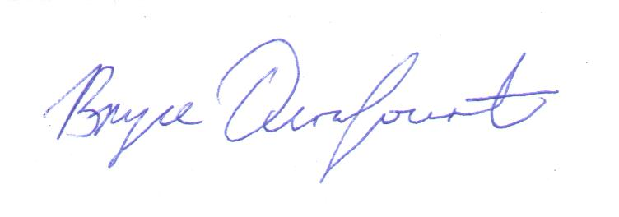

Bryce Durafourt

CFMS President 2014-2015